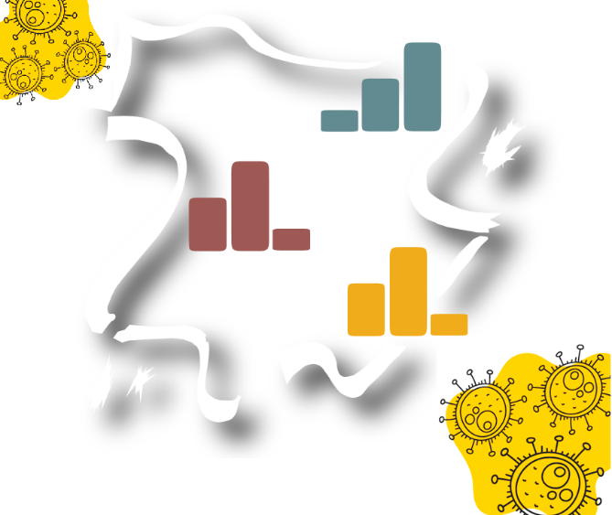



Effects of de-escalation phases on mobility patterns during June 2020 in Spain based on mobile phone data

**Aspiring Data Scientist at Nommon Solutions and Technologies**

Jaime Pizarroso Gonzalo

December 2022

Tabla de contenidos

Executive summary 3

1 Introduction 4

1.1 Scope and Objectives 4

1.2 Motivation 4

1.3 Structure of the document 4

2 Case study, data and methodology 5

2.1 Study area and phases 5

2.2 Data sources 6

2.3 Methodology 7

2.4 Software 8

3 Results 9

3.1 Region level 9

3.1.1 Internal trips 9

3.1.2 Inward trips 9

3.1.3 Outward trips 10

3.2 Province level 10

3.3 Discussion of the results 11

4 Conclusions and future research 12

# Executive summary

This document contains the analysis of the effect of the de-escalation measures applied by the Spanish government during the year 2020 on mobility patterns. The analysis is focused on June 2020 where most of the autonomous communities returned to the new normality phase declared by the government.

The study has used as the main data source the records of the mobile phone antennas once anonymized, complying with current data protection regulations. From them, different indicators-values of mobility between autonomous communities and provinces have been generated. The analysis has focused on the evolution of these values during the month of June.

From this analysis it can be deduced that the mobility levels recovered up to 80-90% of the mobility with respect to the chosen baseline week. However, seasonality effects were not considered in the study, leaving this effect for future research. This document includes a list of other future lines of research that can complement and support this analysis.

During the project, an interactive dashboard has been created for the analysis of the data, which has been made available online and can be used for a wider range of dates than the one used in the project.

This document indicates the databases used in the project and the methodology used.

# Introduction

## Scope and Objectives

The aim of this document is to describe the effect of the de-escalate measures performed by the Spanish government during June 2020 on the mobility patterns between provinces in Spain.

## Motivation

Big data obtained from geolocated devices, such as smartphones, can be used to analyze the impact of COVID-19 on mobility patterns [1][2] between provinces in Spain. This data can provide insights into how the virus is affecting people’s movement between different areas of the country. For example, by tracking the movement of individuals over time, it may be possible to identify changes in the number of people traveling between provinces, as well as changes in the destinations that people are traveling to [3]. This information can be used to understand the impact of the virus on regional mobility and to inform public health interventions. Additionally, analyzing mobility patterns can help identify trends and changes in behavior over time, which can provide valuable information for policymakers and researchers as they work to contain the spread of virus in future social emergencies.

## Structure of the document

The document is structured as follows:

* Section 1 defines the main concepts and terms used throughout the document.
* Section 2 provides an overview of the methodology used in the project.
* Section 3 describes and discusses the results of the data analysis,
* Section 4 summarizes the main conclusions and discusses future research directions.

# Case study, data and methodology

## Study area and phases

The selected study area covers all the provinces in Spain. Aggregation of provinces into regions are performed in analysis to provide a better understanding of the mobility dynamics.

Regarding the time frame, the project analyzes the impact of the de-escalate measures performed during June 2020, when most of the autonomous communities transitioned between the phases of lockdown. Two different weeks have been chosen to compare the mobility pattern of June 2020:

* Week of 14-20 February is used as reference week for the mobility patterns with normal activity prior to COVID-19 before the state of alarm.
* Week of 4 - 10 May is used as reference week for the mobility patterns during the state of alarm. Although this week is not during the most restrictive phase of the quarantine, it has been chosen as some of the mobility restrictions were lifted.

It must be noted that a 4-phase transition plan to the New Normal was established on April 28th. The details of this transition plan can be found in [[4]](#_Spanish_government._(2020,). To understand the results obtained, transition phase of the provinces decreed by the Government of Spain must be defined. Figure 1 shows the evolution of de-escalate phases in Spain provinces from May 11th to June 21st, when all the provinces reach the new normality phase. Table 1 shows the dates of the study weeks, relating them to the de-escalation phases indicated in Figure 1.

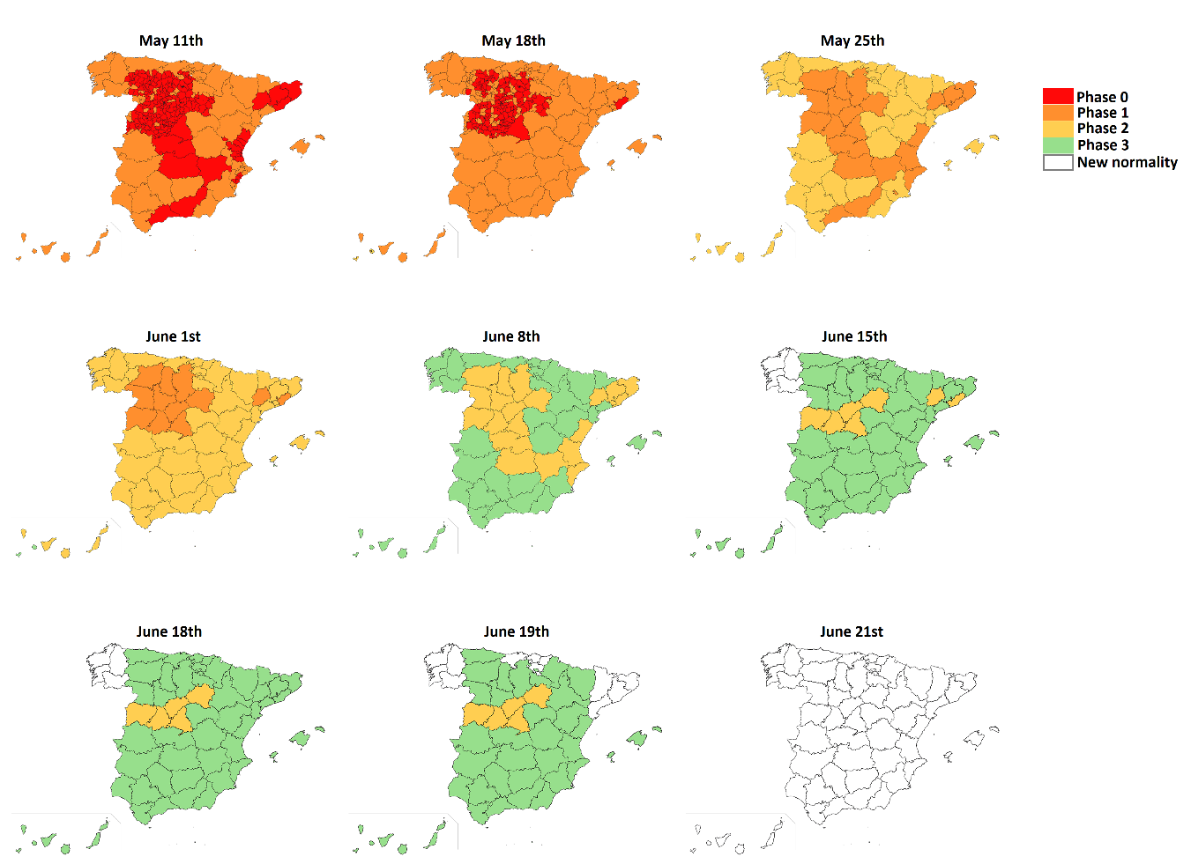

Figure 1. De-escalate phases in Spain, colored by provinces.

|  |  |  |
| --- | --- | --- |
| Study weeks | Dates | Corresponding phase |
| W0 | 14-20 February | Reference week for normal activity prior to COVID-19, before the state of alarm. |
| W1 | 4-10 May | Second reference week for normal activity during COVID-19, during the state of alarm. |
| W2 | 1-7 June | First week of June 2020, where most provinces are in phase 2 and general mobility is not allowed. |
| W3 | 8-14 June | Second week of June 2020, where most provinces enters phase 3 and general mobility is allowed. |
| W4 | 15-21 June | Third week of June 2020, where all provinces transition between phase 2 or 3 to new normality phase. |
| W5 | 22-28 June | Fourth week of June 2020, where all provinces are in new normality phase. |

Table 1. Study weeks, dates and correspondence with the de-escalation phases

## Data sources

The data sets on which this study is based are described below:

1. **Mobile phone records**. This data for the extraction of mobility indicators. It consists of a set of records of mobile phone antennas which, once anonymized, comply with current data protection regulations. This data set is provided by the Spanish ministry of transport, mobility and urban agenda [[5]](#_Spanish_Government._(n.d.).).
2. **Data on State of Alarm phases and measures**. They come from the Royal Decree of the Ministry of the Presidency of the Government of Spain published in the Official State Gazette [[4]](#_Spanish_government._(2020,_1).
3. **Epidemic data**. Data on the number of coronavirus infections and deaths [[6]](#_Sánchez,_S._(2022,)[[7]](#_Datadista._(2022,_April). This data is important as the mobility patterns shall not only be affected by the de-escalation measures but also by the COVID-19 situation in the different provinces.
4. **Geographic data**. Data in geojson format with provinces and regions geographic limits were downloaded from [[8]](#_opendatasoft._(n.d.)._Municipalitie).

## Methodology

The main steps of the data analysis are presented in

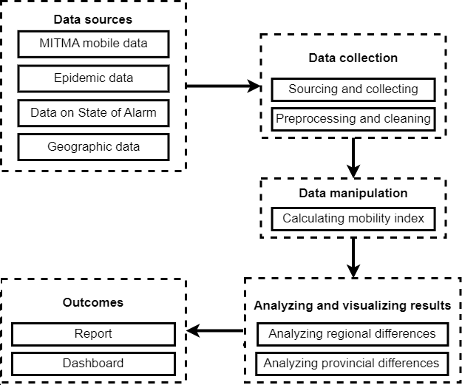

Figure 2: Diagram of the methodology used in the Project

Epidemic and State of alarm data require no preprocessing and are treated as is. However, MITMA mobile data includes daily number of trips which needs to be preprocessed before the analysis phase. First, daily data of trips was aggregated on provincial levels. Internal (trips with origin and destination within the same province), outward (trips that end in a different province but start in the same province) and inward (trips that end in the same province but start in a different one) are calculated. These metrics are calculated on a daily basis. The following origin-destination matrix shows how inward, outward and internal trips are calculated:

Figure 3: OD matrix indicating how indexes can be calculated based on trips between provinces.   
Source: Joint Research Centre (JRC)

The mobility index calculated in this project is the number of trips divided by the amount of trips of the reference week. This index can be calculated by inward, outward, internal, or total trips.

## Software

The following software were used:

* Microsoft Excel (for data storage)
* Python, Visual Studio Code (for data cleaning and preprocessing)
* R programming language, RStudio IDE (for dashboard and data analysis)

The project is saved in <https://github.com/JaiPizGon/open-data-movilidad>. Dashboard can be found in <https://jaipizgon.shinyapps.io/mitma/>.

# Results

## Region level

### Internal trips

Figure 4. Mobility indicator for internal trips, W0 as week of reference. Each line is a region. Weeks are colored in blocks

Figure 4 shows the mobility indicator for internal trips, using W0 as week of reference. All regions show a flat trend, having spikes in some regions which are on holidays (for example, June 9th and 11th was holiday for Murcia and La Rioja regions). Those spikes might be explained by the lack of transport due to workers staying at home for the holiday.

Lowest line is the Community of Madrid, which is not recovered compared to W0 but shows a higher number of internal trips on the weekends. Highest line is Melilla, which seems to be recovered compared to W0. All the rest of regions seems to have a 90% of internal trips compared to February.

### Inward trips

Figure 5. Mobility indicator for inward trips, W0 as week of reference. Each line is a region. Weeks are colored in blocks.

Figure 5 shows the mobility indicator for inward trips, using W0 as week of reference. All regions show a rising trend, with a greater difference in indicator levels at W5. This corresponds with the transition to new normality phase of almost all communities, where restrictions to travel to other regions were lifted.

There are two clearly groups of lines: Islands (Canary, Ballears) and Melilla, and the rest of communities. The latter seems to not have recovered from the tourism they received in February, while the rest seems to have surpassed the inward trips. This could be caused by the tourism of the summer season which begin at the end of June.

Figure 6. Mobility indicator for inward trips, W1 as week of reference. Each line is a region. Weeks are colored in blocks.

Figure 6 shows the mobility indicator for inward trips, using W1 as week of reference. Compared with the state of alarm where most of the restrictions were being applied, inward trips of the regions increased notably. This effect is greater at weekends, when people tend to move to their home towns to see family. It must be noted that the peaks at weekend increase as more regions transition to higher phases of the transition plan.

### Outward trips

Outward trips show similar results to the inward trips.

## Province level

Two leaflet maps are created to analyze how the mobility dynamics changed during June 2020. First plot contains the annual total number of trips between provinces during 2017 (internal trips are also plotted). Second plot contains the total number of trips between provinces in June 2020.

Figure 7. Flow maps of trips between provinces in Spain. Left plot: annual total number of trips during 2017. Right: total number of trips during June 2020.

As can be seen, most of the interprovincial trips were severely reduced, and most of the trips happened inside the same province. This makes sense, as the travel restrictions prevented travel between provinces but travel inside the same province was legal for most provinces even in some of the early phases of the transition plan.

## Discussion of the results

The baseline periods used both for mobile data is relatively short compared to the length of the examined timeframe. For this reason, it is difficult to determine what changes are due to the pandemic and what are due to seasonal changes (for example when summer is compared to the baseline in winter). A better baseline should have been chosen, such as June 2019, but it is not available in the datasets. In this case, the baseline was given and could not be extended, but seasonal effects were discussed in the previous analysis.

Moreover, active coronavirus cases might be a good indicator for representing the severity of the pandemic. Although not analyzed, other studies might have found a correlation between the number of infected/dead persons and the mobility index discussed in this article. A plot of the evolution of these two quantities related to the pandemic is available in the dashboard and can be used for future research.

# Conclusions and future research

This report analyzes how the de-escalation measures affected mobility in Spain at autonomous community and provincial levels during June 2020, where most of the de-escalation phases took place. It is based on datasets available to the public by the Spanish government. The data sources, the methodology and the results were presented in this report. Moreover, an online dashboard based on R Shiny library have been made available for further research based on the data, with a wider timeframe including first stages of the pandemic in Spain.

As a reaction to the pandemic, the first state of alarm was imposed on March 13with hard lockdown prohibiting all non-essential movements. Movements between provinces dropped to minimal levels until first phases of de-escalation. After most restrictions were lifted, mobility levels returned to 80-90% of the baseline week in February. Compared to the baseline in May, mobility levels raised to 250-500% at weekends. This might be caused by an increment due to family travels to other provinces, while work trips happen inside the same province. Despite this increment, interprovince mobility were severely reduced compared to 2017. Moreover, this mobility levels might be affected by the season of the year (it is likely than in summer a higher number of people travels out of the cities), and further investigation must be made to determine if mobility levels were recovered due to the de-escalation measures.

Future research topics on this timeframe might include:

* Effect of holidays: difference between provinces shall be increased between touristic destinations and cities where residents tend to leave.
* Movement restrictions imposed by the administration: lack of well-structured data of movement restrictions make this topic too demanding for this project. However, a database on government responses to the pandemic would facilitate examining the impact of measures on mobility patterns.
* Use of public vs private transport during pandemic: it is likely that the perceived safety of different forms of transportation varied among individuals and communities. In general, private modes of transportation, such as personal vehicles, may have been viewed as safer by some people because they allow for greater control over the environment and who is present. This may have led to an increase in the use of private transportation during the pandemic.
* Companies’ policies: it is an accepted fact that mobility patterns were greatly affected by the adoption of teleworking. However, differences shall arise between provinces with a higher number of companies dedicated to certain sectors, as adoption of telework might not be feasible for some sectors (for example, agricultural).

References

#### Zhou, C., Su, F., Pei, T., Zhang, A., Du, Y., Luo, B., Cao, Z., Wang, J., Yuan, W., Zhu, Y., Song, C., Chen, J., Xu, J., Li, F., Ma, T., Jiang, L., Yan, F., Yi, J., Hu, Y., … Xiao, H. (2020). **Covid-19: Challenges to GIS with big data. Geography and Sustainability**, 1(1), 77–87. <https://doi.org/10.1016/j.geosus.2020.03.005>

#### Oliver, N., Lepri, B., Sterly, H., Lambiotte, R., Deletaille, S., De Nadai, M., Letouzé, E., Salah, A. A., Benjamins, R., Cattuto, C., Colizza, V., de Cordes, N., Fraiberger, S. P., Koebe, T., Lehmann, S., Murillo, J., Pentland, A., Pham, P. N., Pivetta, F., … Vinck, P. (2020). **Mobile phone data for informing public health actions across the COVID-19 pandemic life cycle**. Science Advances, 6(23). <https://doi.org/10.1126/sciadv.abc0764>

#### Romanillos, G., García-Palomares, J. C., Moya-Gómez, B., Gutiérrez, J., Torres, J., López, M., Cantú-Ros, O. G., &; Herranz, R. (2021). **The city turned off: Urban Dynamics during the covid-19 pandemic based on mobile phone data**. Applied Geography, 134, 102524. <https://doi.org/10.1016/j.apgeog.2021.102524>

#### Spanish government. (2020, April 28). **Plan de desescalada [Consejo de Ministros]**. Retrieved December 6, 2022, from <https://www.lamoncloa.gob.es/consejodeministros/Paginas/enlaces/280420-enlace-desescalada.aspx>

#### Spanish Government. (n.d.). **Open data Movilidad, Ministerio de Transportes, Movilidad y Agenda Urbana**. Retrieved December 6, 2022, from <https://www.mitma.gob.es/ministerio/covid-19/evolucion-movilidad-big-data/opendata-movilidad>

#### Sánchez, S. (2022, January 3). **Navigating the COVID-19 pandemic: Artificial Intelligence, natural language generation, and the COVID-19 Tracking Project**. Retrieved December 6, 2022, from <https://www.narrativa.com/navigating-the-covid-19-pandemic-artificial-intelligence-natural-language-generation-and-the-covid-19-tracking-project/>

#### Datadista. (2022, April 22). **Evolución de la Vacunación contra la covid-19 en España**. Retrieved December 6, 2022, from <https://www.datadista.com/coronavirus/evolucion-de-la-vacunacion-en-espana/>

#### opendatasoft. (n.d.). **Municipalities - Spain**. Retrieved December 7, 2022, from <https://data.opendatasoft.com/explore/dataset/georef-spain-municipio%40public/export/?disjunctive.acom_code&amp;disjunctive.acom_name&amp;disjunctive.prov_code&amp;disjunctive.prov_name&amp;disjunctive.mun_code&amp;disjunctive.mun_name>